BEACONHOUSE NATIONAL UNIVERSITY


LAB 4 | WEEK 4

Name: Saad Mughal
BNU ID: F2023-009

Due Date: 6 Mar, 2025

Lab Manual
For
ADMS(SEC_B)
Course Instructor | Ms. Talia Noreen
Lab Instructor | Mr. Ahsan Atiq
Semester | Spring 2025

1.) List all students along with the courses they have enrolled in.
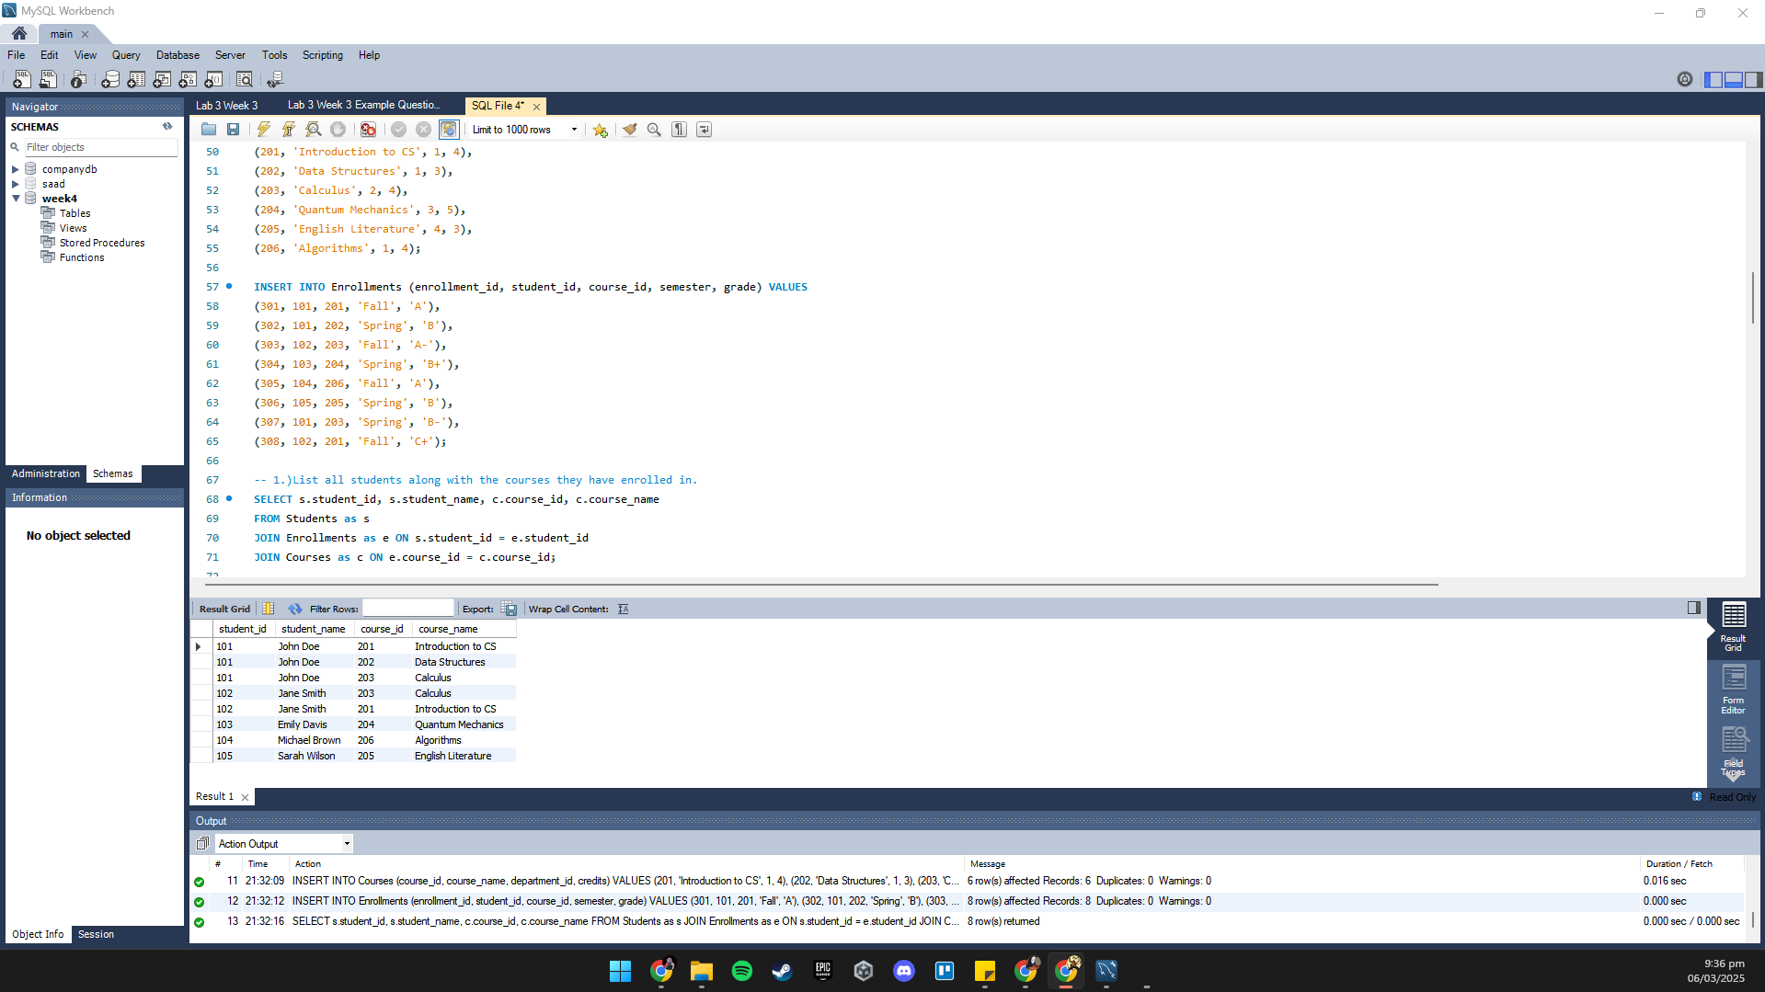

2.) Find the names of students who have taken courses offered by the Computer Science department.

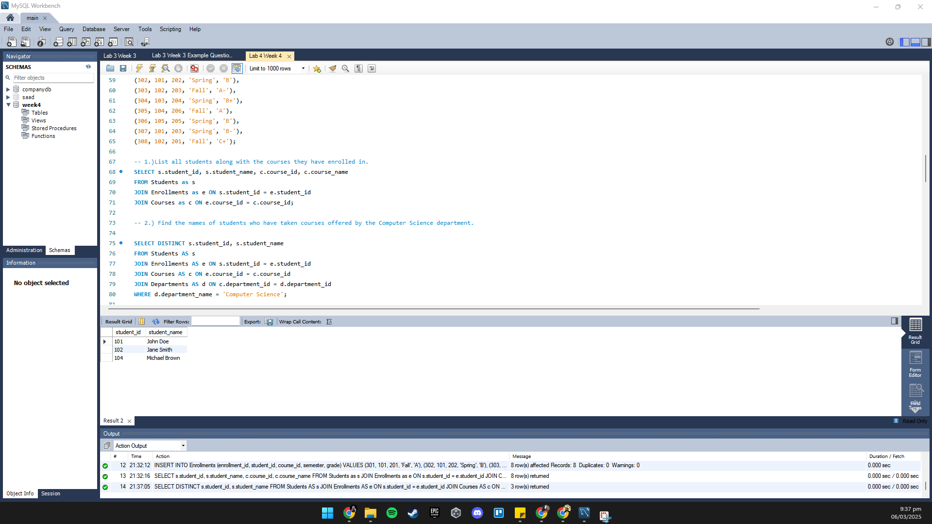

3.) Show the grades obtained by each student for each course in the Fall semester.
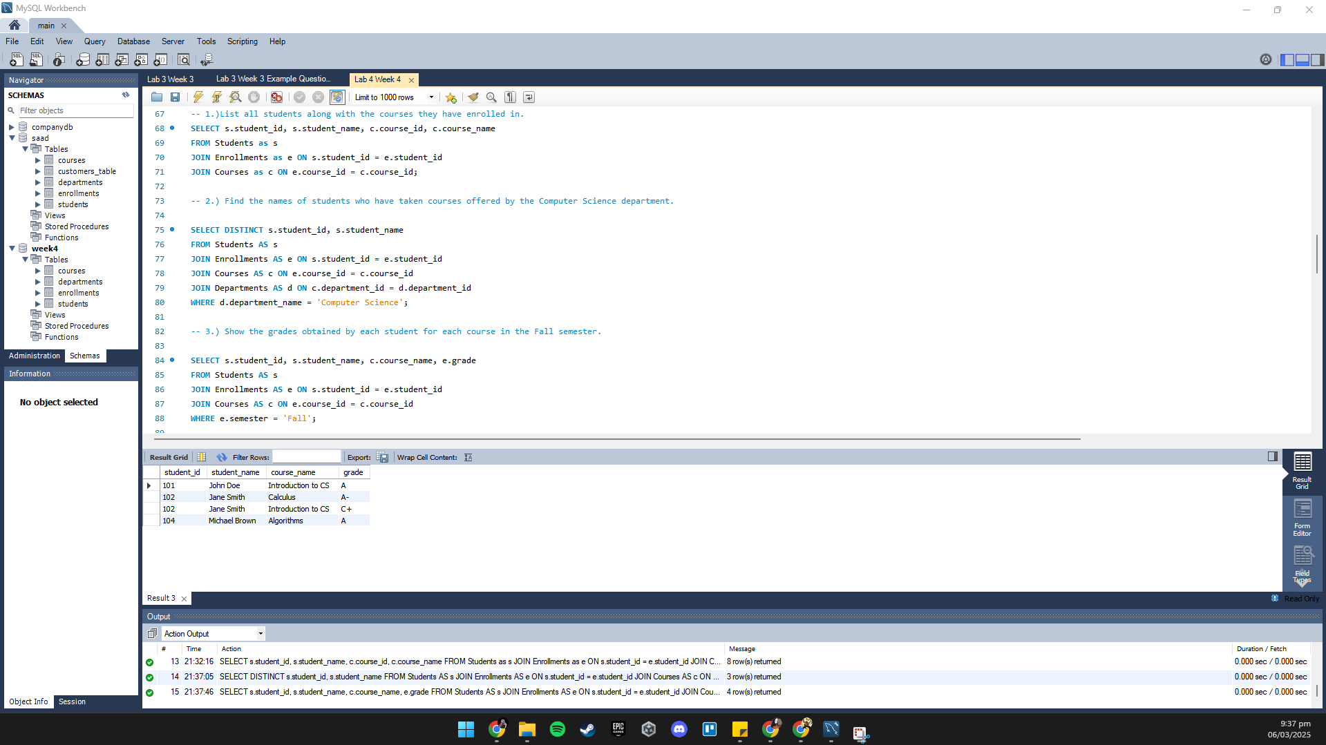

4.) List all students and the courses they have taken, including students who have not enrolled in any courses.

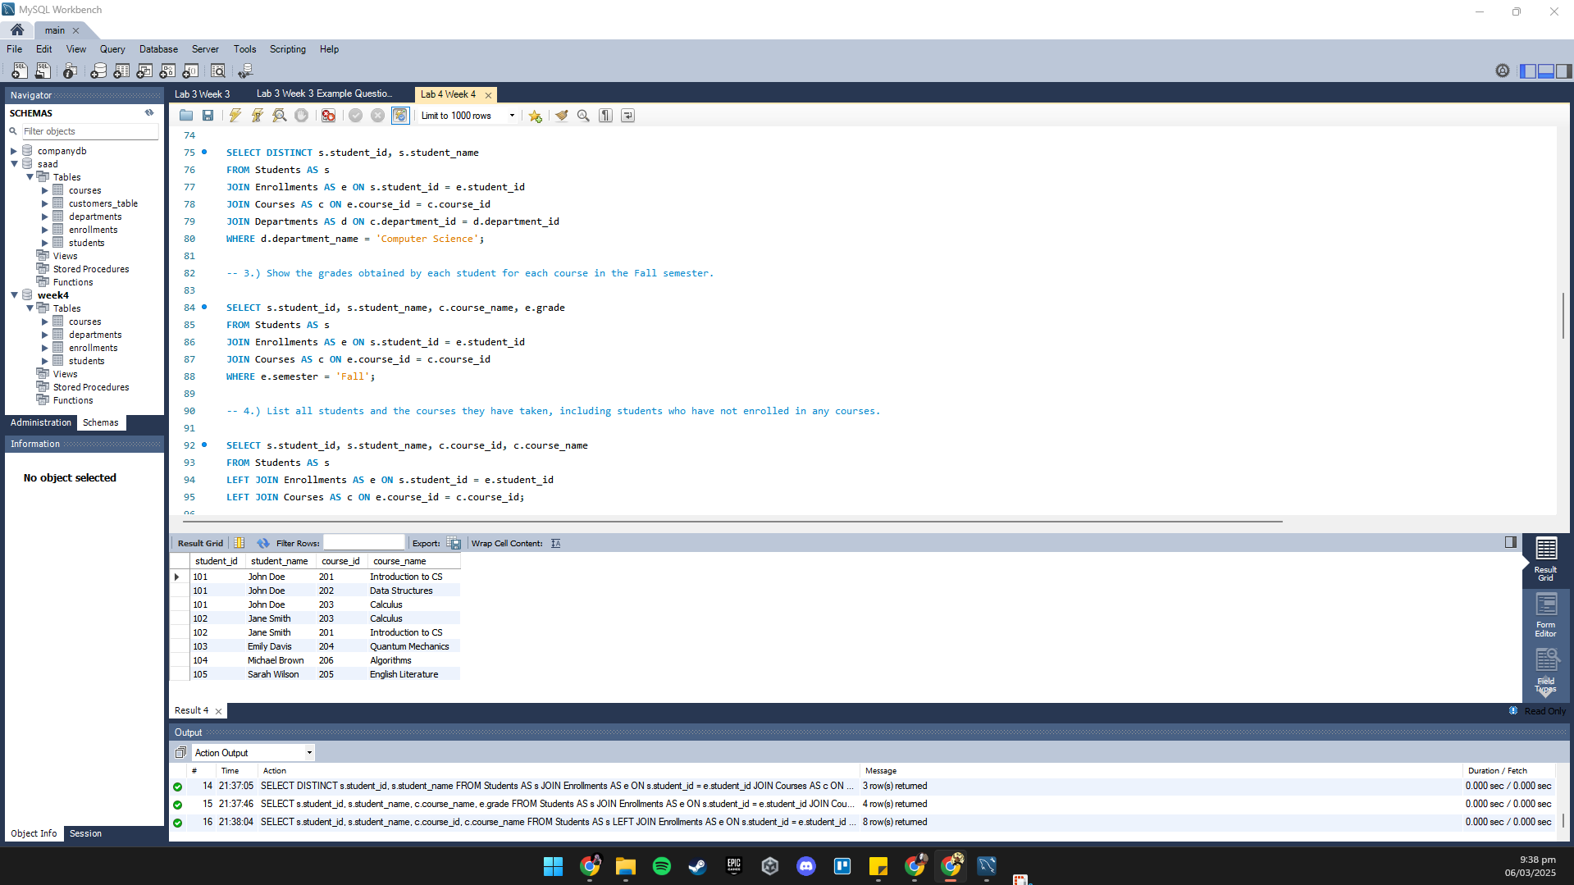

5.) Display all courses along with the names of students enrolled in them, even if a course has
no students enrolled.
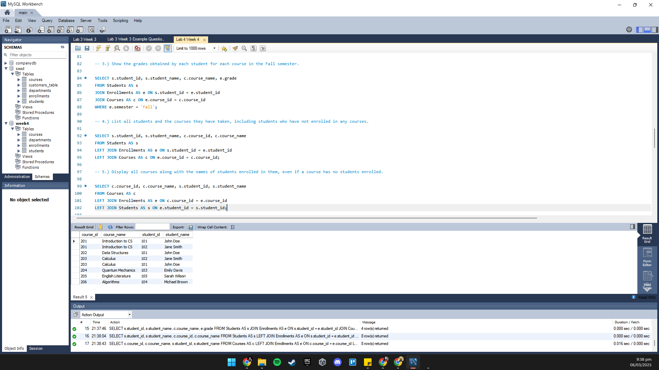

6.) List all enrollments, including details about students even if the course information is not
available.
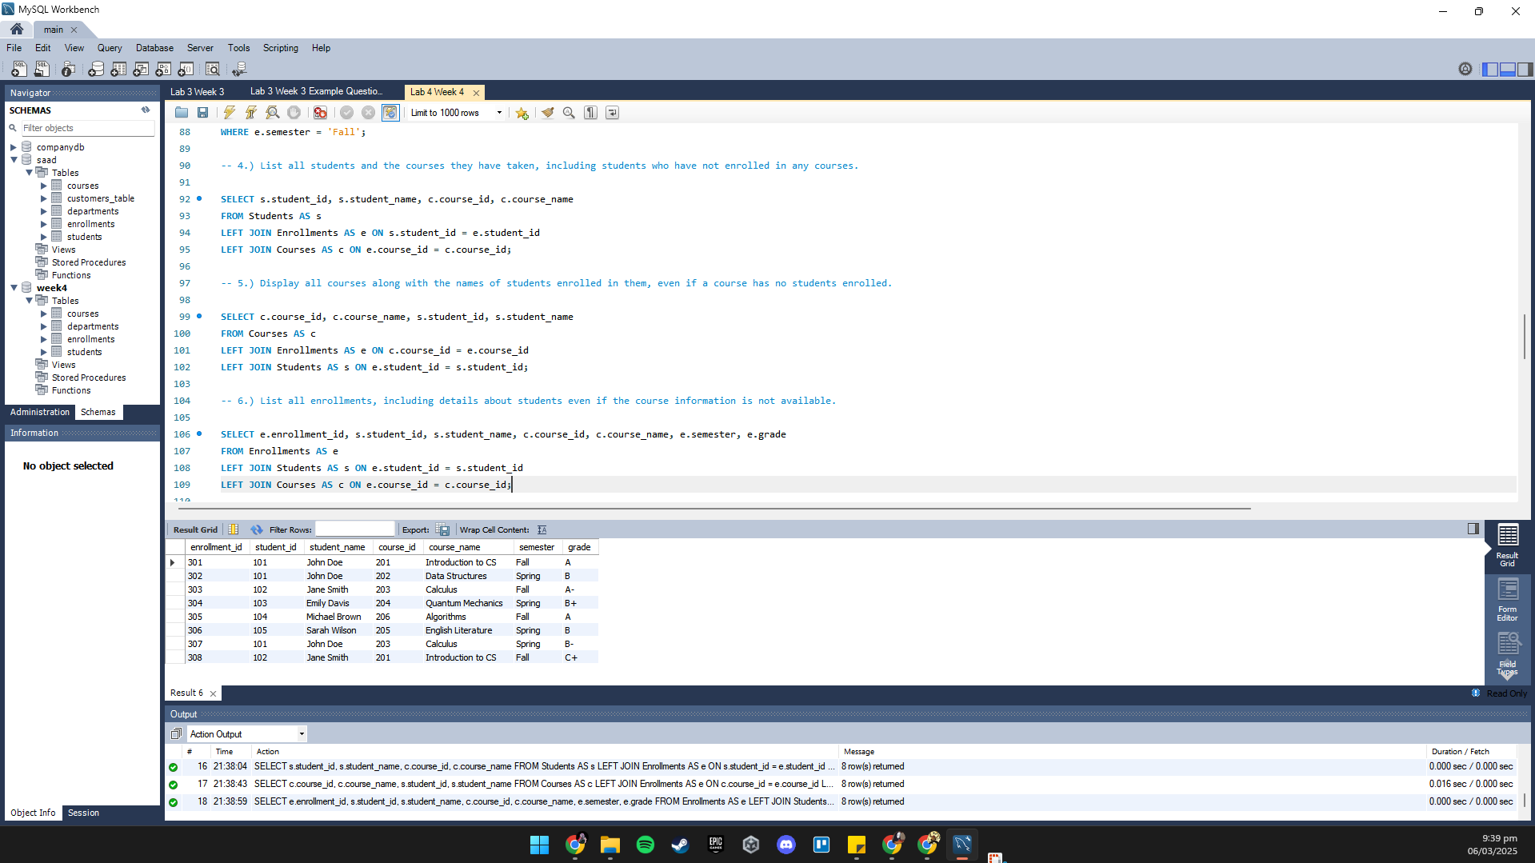

7.) Generate a list of all possible student-course pairs, even if a student is not enrolled in the
course.

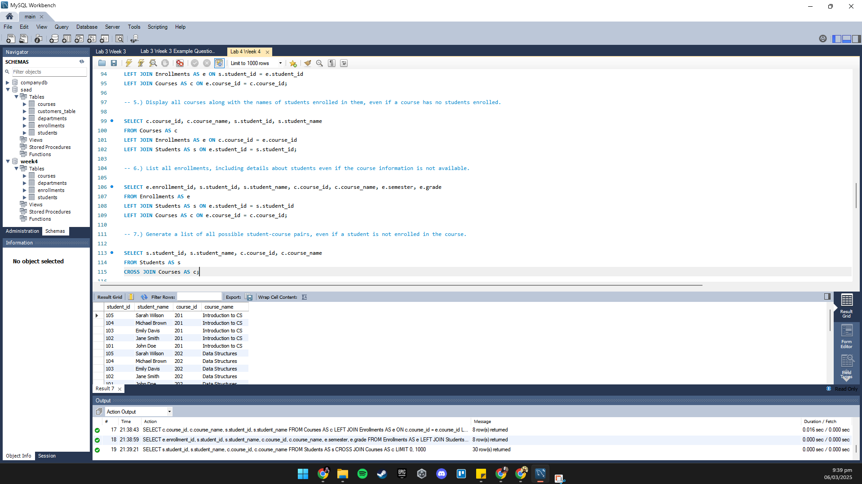

8.) Find pairs of students who are in the same department.
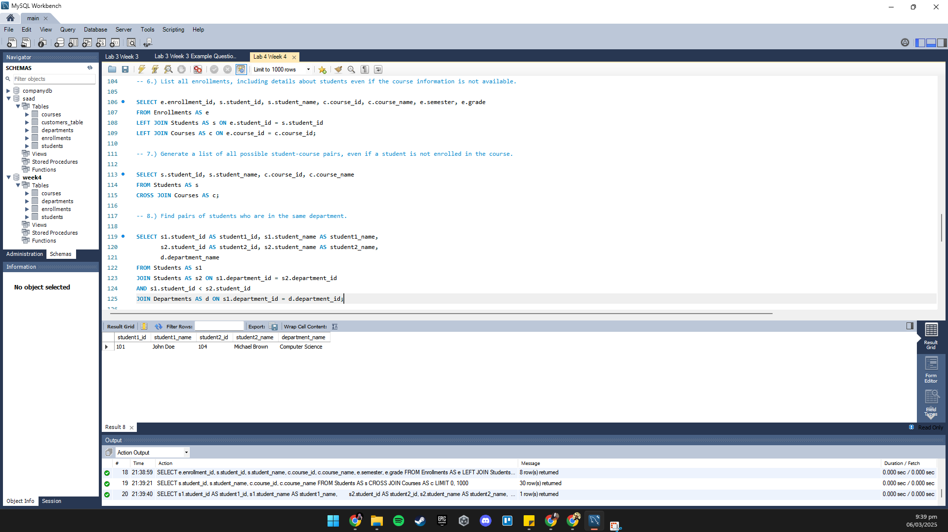

9.) Identify departments where multiple students enrolled in the same year.
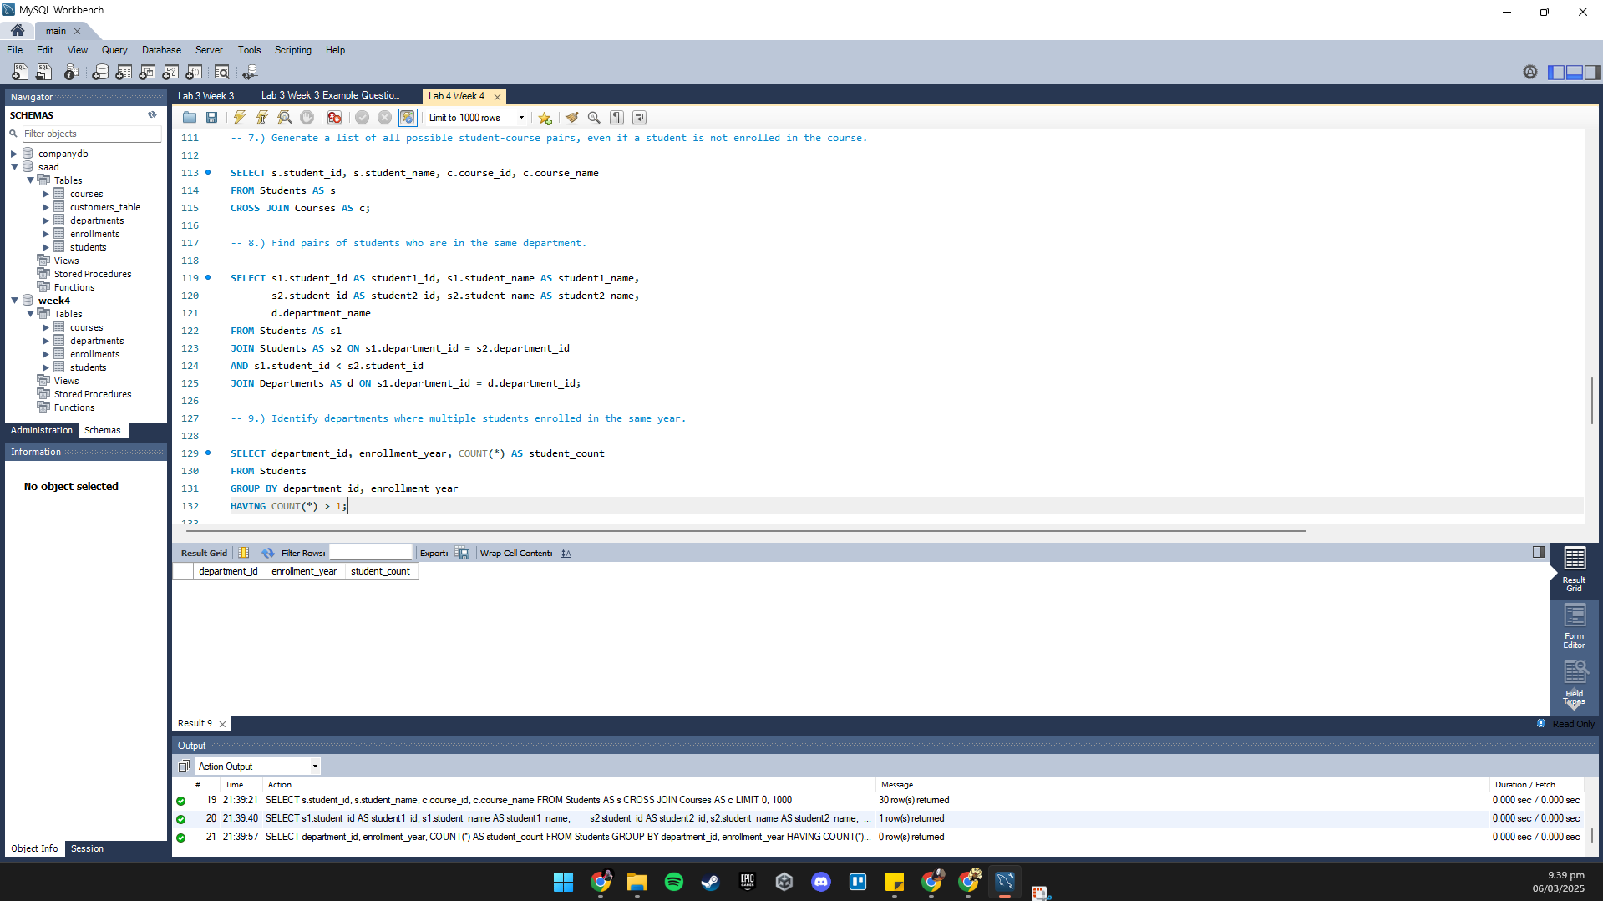

10.) List the students who have taken courses outside their department and the grades they
obtained.

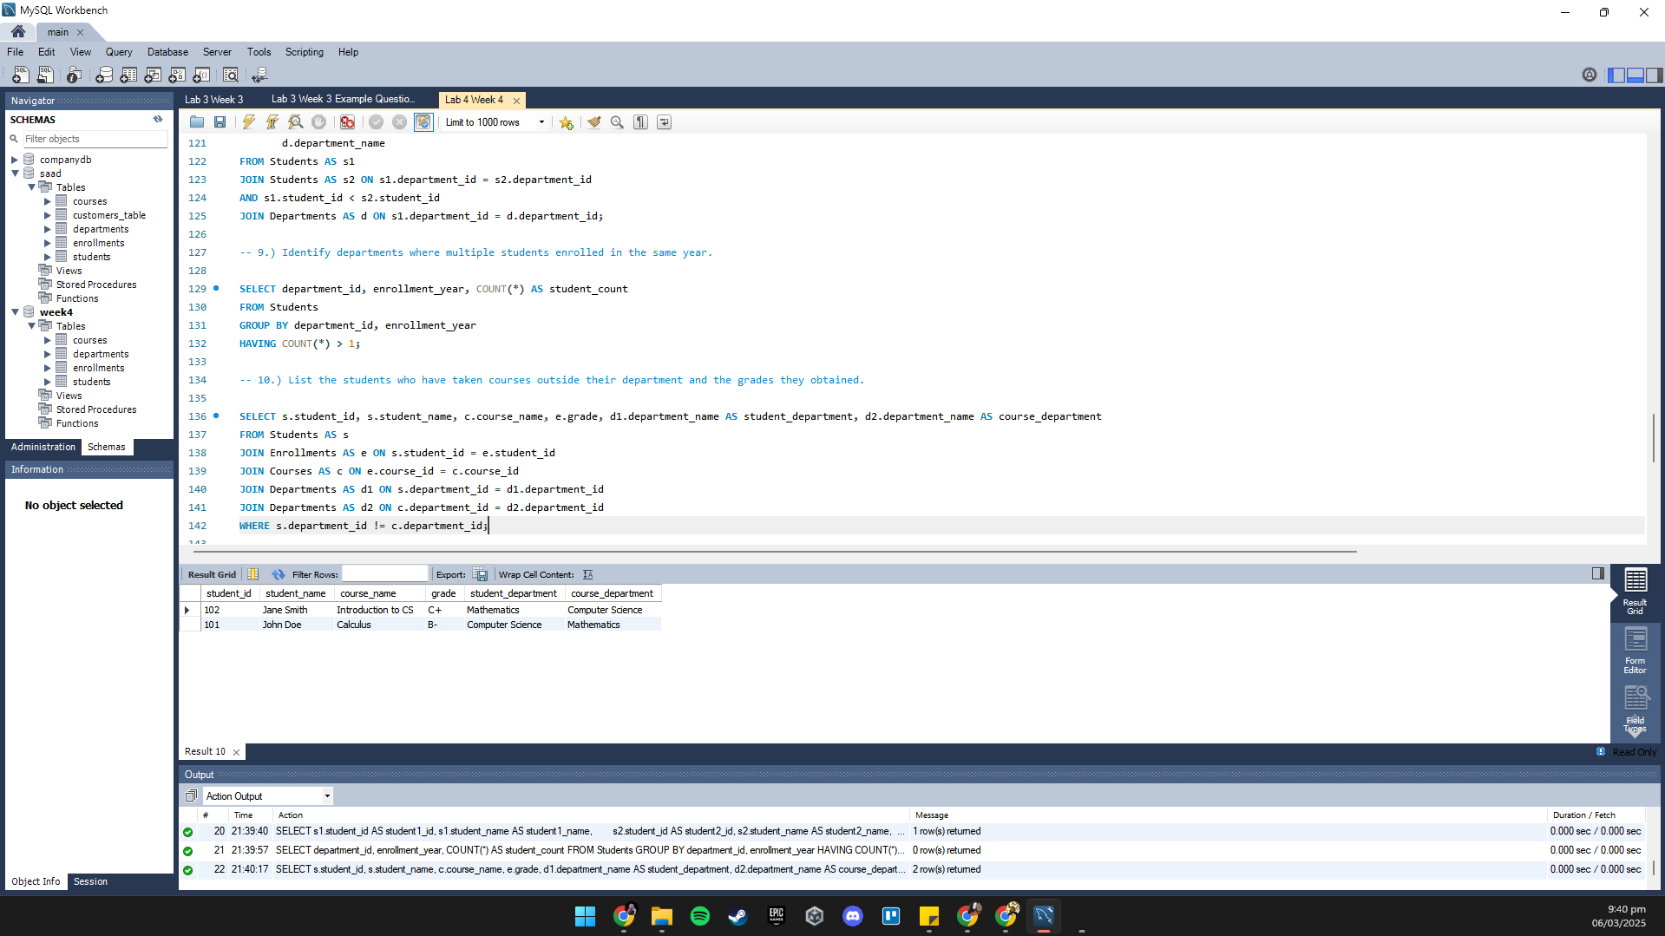

11.) Find the department heads whose departments have the most students enrolled in courses for the Fall semester.

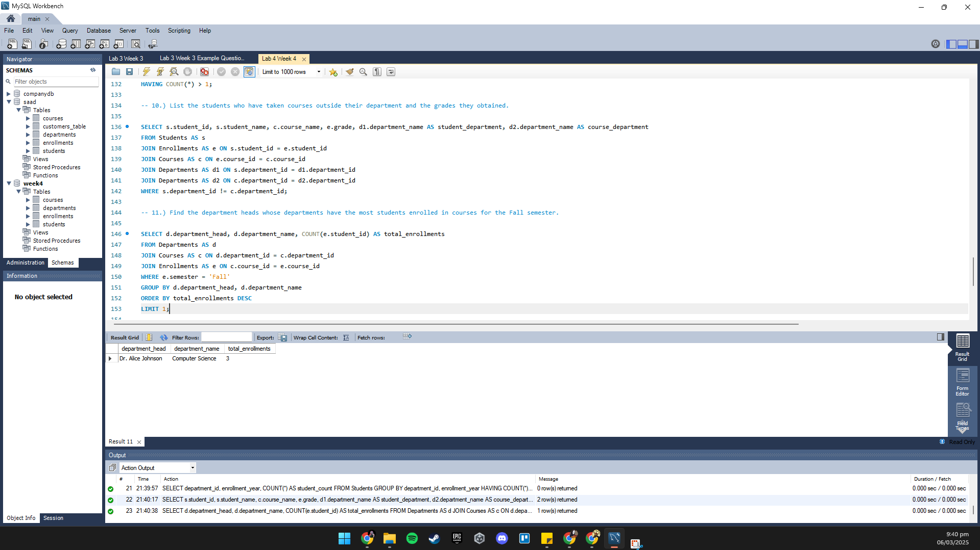

12.) Show the average grade per course for each department.
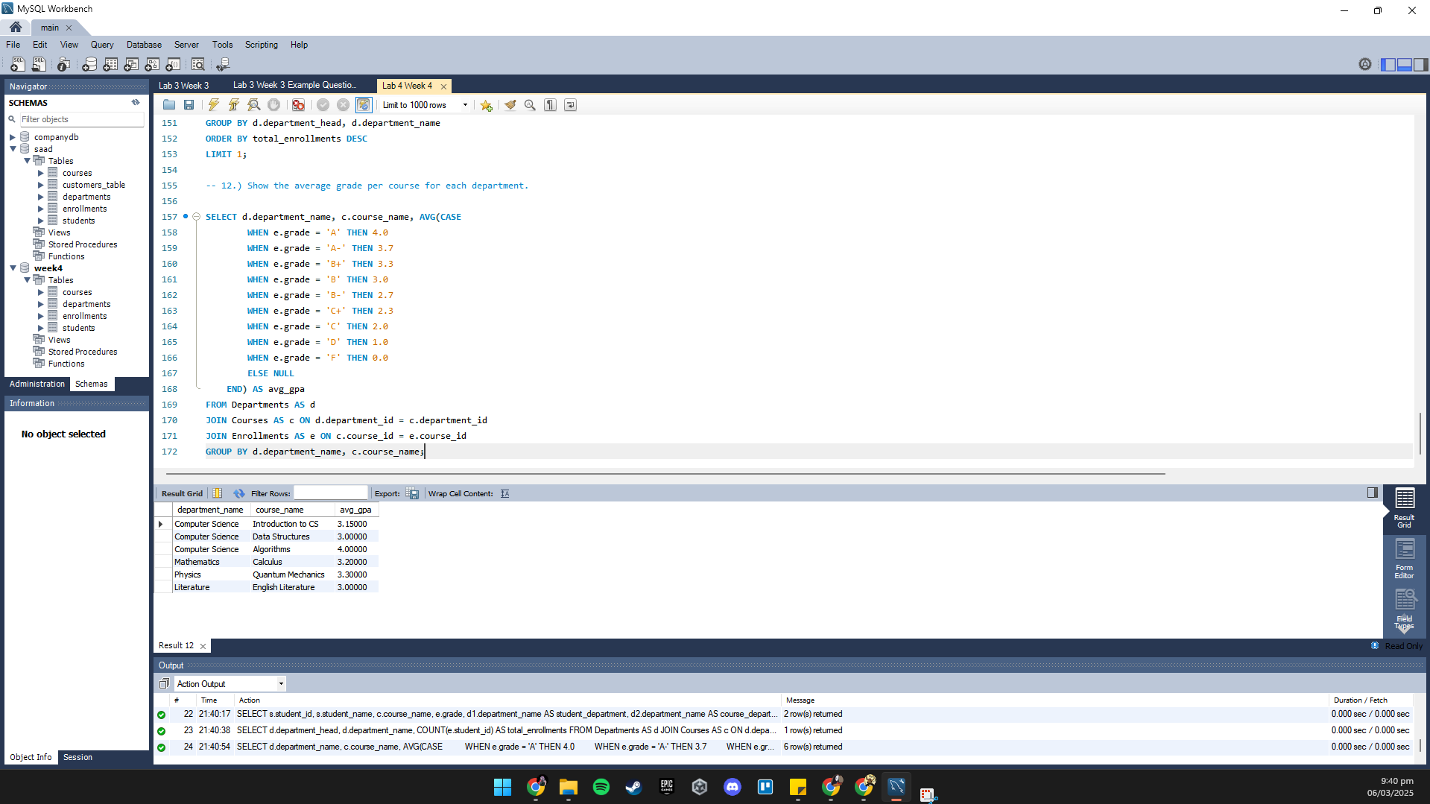

Example Questions from Lecture 3 slides.
Q1: Display the employee details along with their department names using an INNER JOIN.
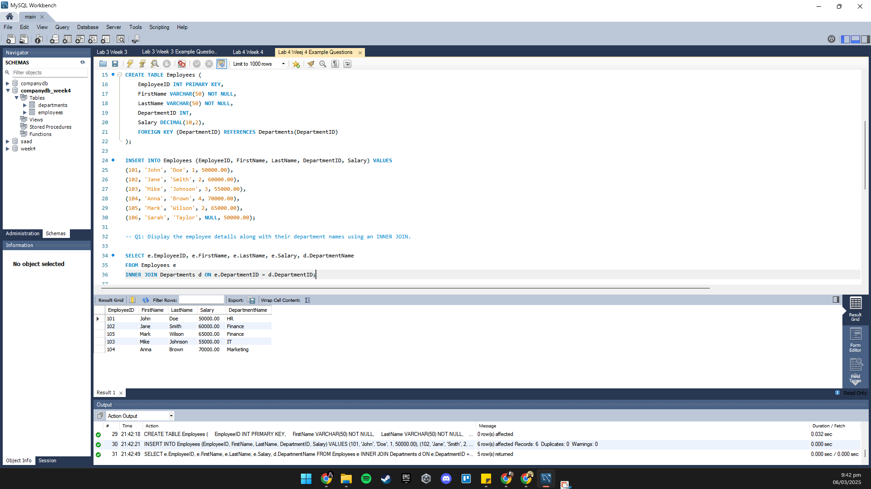

Q2: Display all employees, including those without a department, using a LEFT JOIN.
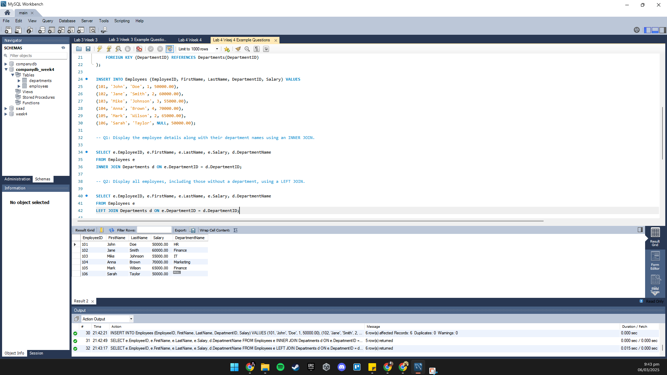

Q3: Display all departments, including those without any employees, using a RIGHT JOIN.

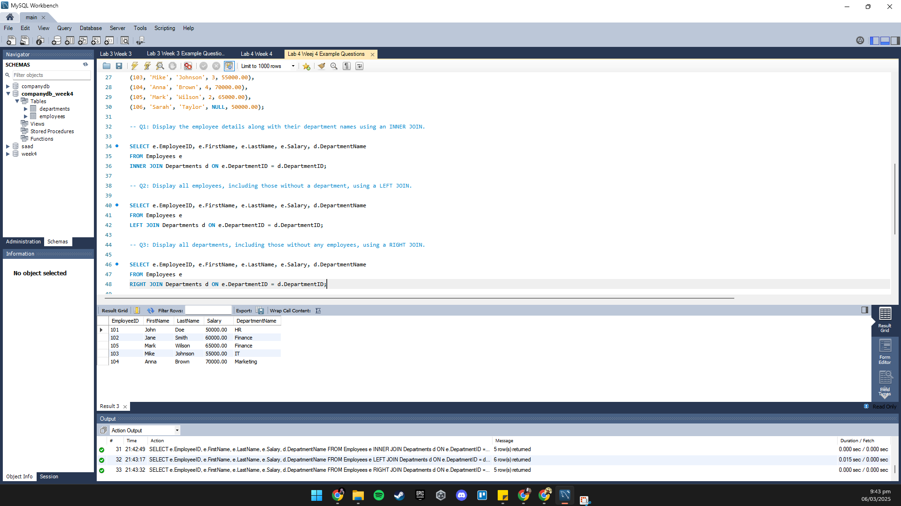

Q4: Display all possible combinations of employees and departments using CROSS JOIN.

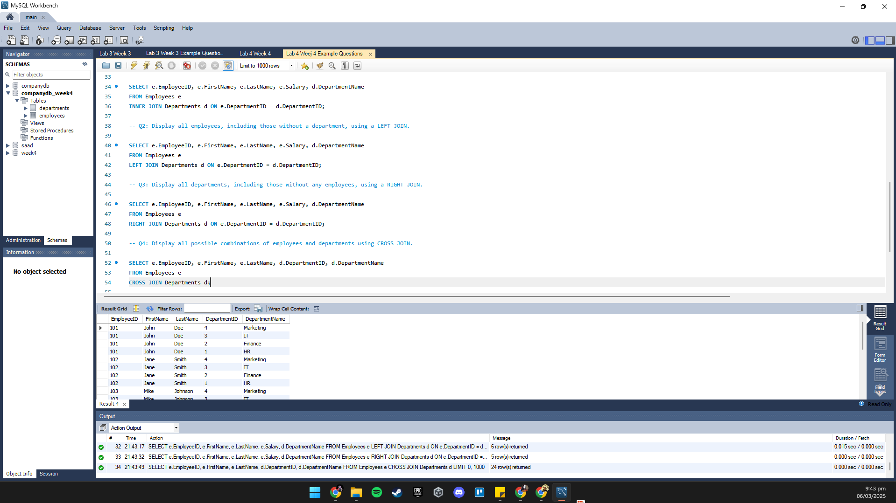

Q5: Display pairs of employees who work in the same department.
